**Program 1: Abstraction with Youtube Videos**

In this program, the Comment class retrieves a singular comment on the video along with the name of the person who left the comment. The Video class gets all the information about the video itself including the title, author, and length of the video. It also uses the Comment class to retrieve and store a list of all the individual comments with the name of their commenter. Finally, the video class will figure out the number of comments based on how many items are in the list of comments.

**Program 2: Encapsulation with Online Ordering**

In this program, the Order class stores a list of products which is retrieved and stored from the product class. It also retrieves and stores customer from the Customer class. As for the methods, it gets the total cost of the order as well as the two labels needed for each order. The Product class, which was pulled to get a list of products, gets the name, ID, price, and quantity of the product. These are all the things passed into the list. This class also calculates the price of just the product. Next, the Customer class, which was also pulled, gets the name and the address of each customer. It gets the address from the Address class. It also checks whether or not the customer is a USA resident (using a method in the address class that checks whether or not the address is in the USA). Lastly, the Address class, which was pulled into customer, gets all details of the customer’s address (street, city, state, country). It then, as stated previously, checks if the address is in the USA. It also gets a string of all address items.

**Program 3: Inheritance with Event Planning**

The purpose of this program is to organize and market events. That being said, it has a parent class named Events. The 3 types of events are also classes (Lecture, Reception, and OutdoorGathering) and will inherit the information from Event. This information includes the title of the event, the description, the date, the time, and the address. The address is pulled from the Address class, which holds the street, city, state, and zip code. It then uses all this information to get a string containing the full address. The methods GetStandardDetails and GetShortDescription contain all the same details for each event, so those are only stored in the Event class. GetFullDetails requires some differing information between each class, so they will all inherit and override this method from the Event class. Lecture requires the addition of speaker name and capacity. Reception requires the email of all attendees who have RSVP’d. Lastly, OutdoorGathering requires the weather forecast.

**Program 4: Polymorphism with Exercise Tracking**

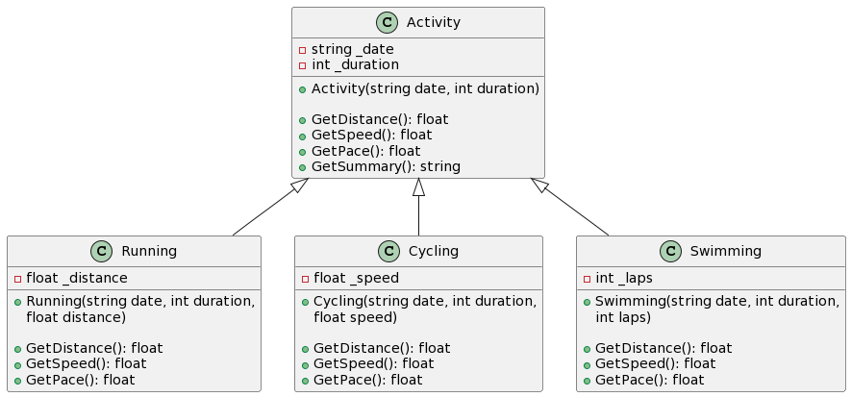

The purpose of this program is to track exercises for customers at a fitness center. The parent class is Activity. It holds the date and duration of each activity which will then be inherited by each of the child classes (Running, Cycling, and Swimming). Each of the child classes also need to get the distance, speed, and pace of the activity, so these virtual methods are placed in the Activity class, then inherited and overridden in each of the child classes based on their differing needs. The Activity class also gets a string containing all of the information associated with each workout. Each of the child classes takes in a single differing parameter which is used to calculate the distance, speed, and pace for each of the different exercises. For running it is distance, for cycling it is speed, and for swimming it is the number of laps.